**1. INTRODUCTION**

**1.1. About C++**

C++ is an object oriented programming (OOP) language, developed by Bjarne Stroustrup, and is an extension of C language. It is therefore possible to code C++ in a "C style" or "object-oriented style." In certain scenarios, it can be coded in either way and is thus an effective example of a hybrid language.

C++ is a general purpose object oriented programming language. It is considered to be an intermediate level language, as it encapsulates both high and low level language features. Initially, the language was called 'C with classes’ as it had all properties of C language with an additional concept of 'classes’. However, it was renamed to C++ in 1983.

It is pronounced "C-Plus-Plus". C++ is one of the most popular languages primarily utilized with system/application software, drivers, client-server applications and embedded firmware.

The main highlight of C++ is a collection of pre-defined classes, which are data types that can be instantiated multiple times. The language also facilitates declaration of user defined classes. Classes can further accommodate member functions to implement specific functionality. Multiple objects of a particular class can be defined to implement the functions within the class. Objects can be defined as instances created at run time. These classes can also be inherited by other new classes which take in the public and protected functionalities by default.

C++ includes several operators such as comparison, arithmetic, bit manipulation, logical operators etc. One of the most attractive features of C++ is that it enables the overloading of certain operators such as addition.   
  
A few of the essential concepts within C++ programming language include polymorphism, virtual and friend functions, templates, namespaces and pointers.

**1.2. Overview of Files Concept**

**1.2.1. File handling:**

File handling concept in C++ language is used for store a data permanently in computer. Using file handling we can store our data in Secondary memory (Hard disk).

**1.2.2. Use of file handling:**

* For permanent storage.
* The transfer of input - data or output - data from one computer to another can be easily done by using files.

For read and write from a file you need another standard C++ library called stream which defines three new data types:

|  |  |
| --- | --- |
| **Data type** | **Description** |
| Ofstream | This is used to create a file and write data on files |
| Ifstream | This is used to read data from files |
| Fstream | This is used to both read and write data from/to files |

**1.2.3. How to achieve File Handling**

For achieving file handling in C++ we need follow following steps

* Naming a file
* Opening a file
* Reading data from file
* Writing data into file
* Closing a file

**1.2.4. Functions use in File Handling**

|  |  |
| --- | --- |
| **Function** | **Operation** |
| open() | To create a file |
| close() | To close an existing file |
| get() | Read a single character from a file |
| put() | write a single character in file. |
| read() | Read data from file |
| write() | Write data into file. |

**1.2.5. Defining and Opening a File**

The function open() can be used to open multiple files that use the same stream object.

**1.2.6. Closing a File**

A file must be close after completion of all operation related to file. For closing file we need **close()** function.

**1.2.7. File Opening mode**

|  |  |  |
| --- | --- | --- |
| **Mode** | **Meaning** | **Purpose** |
| ios :: out | Write | Open the file for write only. |
| ios :: in | read | Open the file for read only. |
| ios :: app | Appending | Open the file for appending data to end-of-file. |
| ios :: ate | Appending | take us to the end of the file when it is opened. |

Both ios :: app and ios :: ate take us to the end of the file when it is opened. The difference between the two parameters is that the ios :: app allows us to add data to the end of file only, while ios :: ate mode permits us to add data or to modify

the existing data anywhere in the file. The mode can combine two or more parameters using the bitwise OR operator (symbol |)

**1.2.8. File pointer**

Each file has two associated pointers known as the file pointers. One of them is called the input pointer (or get pointer) and the other is called the output pointer (or put pointer). The input pointer is used for reading the contents of a given file location and the output pointer is used for writing to a given file location.

**1.2.9. Function for manipulation of file pointer**

When we want to move file pointer to desired position then use these function for manage the file pointers.

|  |  |
| --- | --- |
| **Function** | **Operation** |
| seekg() | moves get pointer (input) to a specified location. |
| seekp() | moves put pointer (output) to a specified location. |
| tellg() | gives the current position of the get pointer. |
| tellp() | gives the current position of the put pointer. |
| fout . seekg(0, ios :: beg) | go to start |
| fout . seekg(0, ios :: cur) | stay at current position |
| fout . seekg(0, ios :: end) | go to the end of file |
| fout . seekg(m, ios :: beg) | move to m+1 byte in the file |
| fout . seekg(m, ios :: cur) | go forward by m bytes from the current position |
| fout . seekg(-m, ios :: cur) | go backward by m bytes from the current position |
| fout . seekg(-m, ios :: end) | go backward by m bytes from the end |

**1.2.10. put() and get() function**

The function put() write a single character to the associated stream. Similarly, the function get() reads a single character from the associated stream.

**1.2.11. rea d() and write() function**

These functions take two arguments. The first is the address of the variable V, and the second is the length of that variable in bytes. The address of variable must be cast to type char * (i.e. pointer to character type).

**2. SYSTEM REQUIREMNETS**

* Operating System: Windows XP, Vista, 7 and 8.
* Processor: Pentium III/1.4GHz Processor
* RAM: 512MB to 2GB
* Hard Disk Space: 900MB space required.
* Compiler: BORLAND / TURBO compiler

**3. OBJECTIVE OF THE PROJECT**

As the name suggests, this project is based on school management system. In this project one can:

* Create student record
* Create faculty record
* Modify them
* View their progress

The source code contains different header files, built-in functions, user-defined functions, switch statements, loop statements, etc.

The main objective of the school Management system project is discipline of the planning, organizing and managing the school tasks. Our project aims at making the tasks of school easy .School Management is entering the records of new students, faculties, non-teaching staff members and retrieving the details of these members available in the memory. Admin being the chief can maintain these records and can also check on the daily tasks. In the project we can maintain the progress of a student and also can maintain the details of the faculty, students, and non-teaching staffs for a longer period of time without being truncated unless the admin wishes .The modified data stores in the already present data by replacing the necessary areas which are wished to be changed by the admin.

**4. HEADER FILES PURPOSES**

**4.1. Header Files Used**

* fstream.h
* iomanip.h
* stdio.h
* conio.h
* string.h
* Process.h
* dos.h

**4.2. Header Files Purposes**

* fstream.h : This header file is used for defining several iostreams template classes that manipulate external files. This is a standard C++ library that handles reading from and writing to files either in text or in binary formats
* iomanip.h : This header file declares stream I/O manipulators and contains macros for creating parameterized manipulators.
* stdio.h : This header file defines types and macros needed for the standard I/O package.
* conio.h : This header file in c++ programming contains functions for console input/output. Some of the most commonly used functions of conio.h are clrscr(), getch(),
* etc.
* string.h : The string.h provides various functions for comparing, coping, concatenating, reversing, and many other functions for various operations.
* process. h : process.h is a C header file which contains function declarations and macros used in working with threads and processes
* dos.h : The dos.h header file of c++ language contains functions for handling interrupts, producing sound, date and time functions etc. It is borland specific and works in turbo c++ compiler.

**5. SOURCE CODE**

**//\*\*\*\*\*\*\*\*\*\*\*\*\*\*\*\*\*\*\*\*\*\*\*\*\*\*\*\*\*\*\*\*\*\*\*\*\*\*\*\*\*\*\*\*\*\*\*\*\*\*\*\*\*\*\*\*\*\***

**// INCLUDED HEADER FILES**

**//\*\*\*\*\*\*\*\*\*\*\*\*\*\*\*\*\*\*\*\*\*\*\*\*\*\*\*\*\*\*\*\*\*\*\*\*\*\*\*\*\*\*\*\*\*\*\*\*\*\*\*\*\*\*\*\*\*\***

**#include<stdlib.h>**

**#include<fstream.h>**

**#include<conio.h>**

**#include<process.h>**

**#include<dos.h>**

**#include<stdio.h>**

**#include<ctype.h>**

**#include<string.h>**

**//\*\*\*\*\*\*\*\*\*\*\*\*\*\*\*\*\*\*\*\*\*\*\*\*\*\*\*\*\*\*\*\*\*\*\*\*\*\*\*\*\*\*\*\*\*\*\*\*\*\*\*\*\*\*\*\*\*\***

**// GLOBAL: CLASS**

**//\*\*\*\*\*\*\*\*\*\*\*\*\*\*\*\*\*\*\*\*\*\*\*\*\*\*\*\*\*\*\*\*\*\*\*\*\*\*\*\*\*\*\*\*\*\*\*\*\*\*\*\*\*\*\*\*\*\***

**void admin();**

**class studentclass**

**{**

**public:**

**char name[30],homeaddress[100],email[30],parentname1[34],parentname2[34];**

**char gender[10],bg[10],mobileno2[10],mobileno1[10],aadharno[12],income[6];**

**int rollno,verify;**

**void students();**

**void showstudent();**

**int getrollno();**

**void showspec_stu(int);**

**void newstudent();**

**void destroystudent();**

**void modifystudent();**

**void searchstudent();**

**/\*\**

**void workers();**

**void officemembers();**

**\*/**

**}user1;**

**class facultyclass**

**{**

**public:**

**char name[30],homeaddress[100],email[30],parentname1[34],parentname2[34];**

**char qualifi[30],gender[10],bg[10],mobileno2[10],mobileno1[10],aadharno[12],income[6];**

**char semail[30],sdesig[50],sname[30],sbg[10],sgender[10],squalifi[50];**

**char smobileno1[10],saadharno[10],smobileno2[10],ans;**

**int code;**

**void faculty();**

**int getcode()**

**{**

**return code;**

**}**

**void showfaculty();**

**void showspec_fac(int);**

**void newfaculty();**

**void destroyfaculty();**

**void modifyfaculty();**

**void searchfaculty();**

**void newstudent();**

**void searchstudent();**

**/\***

**void workers();**

**void officemembers();**

**\*/**

**}user,use[20];**

**//\*\*\*\*\*\*\*\*\*\*\*\*\*\*\*\*\*\*\*\*\*\*\*\*\*\*\*\*\*\*\*\*\*\*\*\*\*\*\*\*\*\*\*\*\*\*\*\*\*\*\*\*\*\*\*\*\*\***

**// GLOBLE FUNCTION FOR EDITTING BY THE ADMIN**

**//\*\*\*\*\*\*\*\*\*\*\*\*\*\*\*\*\*\*\*\*\*\*\*\*\*\*\*\*\*\*\*\*\*\*\*\*\*\*\*\*\*\*\*\*\*\*\*\*\*\*\*\*\*\*\*\*\*\***

**class line**

**{public:**

**void printtask();**

**void edit_task();**

**void attendance();**

**void add_task();**

**void setting();**

**void birthday();**

**void clearup(void);**

**void print();**

**}lin;**

**void line::clearup()**

**{**

**for (int i=25; i>=1; i--)**

**{**

**delay(20) ;**

**gotoxy(1,i) ; clreol() ;**

**}**

**}**

**void line:: print()**

**{**

**clrscr();**

**int i=10,j=8;**

**gotoxy(i,j++);cout<<"ÛßßßßßßßßßÛ";**

**gotoxy(i,j++);cout<<"Û ÜÜÜÜÜ Û";**

**gotoxy(i,j++);cout<<"Û Û Û Û";**

**gotoxy(i,j++);cout<<"Û Û Û Û";**

**gotoxy(i,j++);cout<<"Û ÛÜÜÜÜÜÛ Û";**

**gotoxy(i,j++);cout<<"Û Û Û Û";**

**gotoxy(i,j++);cout<<"Û Û Û Û";**

**gotoxy(i,j++);cout<<"ÛÜÜÜÜÜÜÜÜÜÛ";**

**gotoxy(i,++j);cout<<" |->| ";**

**delay(100);**

**i=35,j=8;**

**gotoxy(i,j++);cout<<"ÛßßßßßßßßßÛ";**

**gotoxy(i,j++);cout<<"Û ÜÜÜÜÜÜÜ Û";**

**gotoxy(i,j++);cout<<"Û Û Û";**

**gotoxy(i,j++);cout<<"Û Û Û";**

**gotoxy(i,j++);cout<<"Û Û Û";**

**gotoxy(i,j++);cout<<"Û Û Û";**

**gotoxy(i,j++);cout<<"Û Û Û";**

**gotoxy(i,j++);cout<<"ÛÜÜÜÜÜÜÜÜÜÛ";**

**gotoxy(i,++j);cout<<" |->| ";**

**delay(100);**

**i=60,j=8;**

**gotoxy(i,j++);cout<<"ÛßßßßßßßßÛ";**

**gotoxy(i,j++);cout<<"Û ÜÜÜÜÜÜ Û";**

**gotoxy(i,j++);cout<<"Û Û Û";**

**gotoxy(i,j++);cout<<"Û Û Û";**

**gotoxy(i,j++);cout<<"Û ßßßßßÛ Û";**

**gotoxy(i,j++);cout<<"Û Û Û";**

**gotoxy(i,j++);cout<<"Û ÜÜÜÜÜÛ Û";**

**gotoxy(i,j++);cout<<"ÛÜÜÜÜÜÜÜÜÛ";**

**gotoxy(i,++j);cout<<" |->| ";**

**//getch();**

**delay(500);**

**char ch,flag=13,c;**

**gotoxy(40,15);**

**while(ch!=13)**

**{**

**once:**

**c=ch;**

**ch=getch();**

**if(ch=='a')**

**{**

**gotoxy(16,17);**

**}**

**if(ch=='s')**

**{**

**gotoxy(66,17);**

**}**

**if(ch=='t')**

**{**

**gotoxy(41,17);**

**}**

**}**

**lin.clearup();**

**switch (c)**

**{**

**case 'a':admin();break;**

**case 't':user.faculty();break;**

**case 's':user1.students();break;**

**}**

**}**

**void line:: birthday()**

**{int i=11,j=57;**

**gotoxy(j,i++);cout<<"É------------------» ";**

**gotoxy(j,i++);cout<<"|WHISHING MANY MORE|";**

**gotoxy(j,i++);cout<<"|RETURNS OF THE DAY|";**

**gotoxy(j,i++);cout<<"| É » TO É » |";**

**gotoxy(j,i++);cout<<"| |";**

**gotoxy(j,i++);cout<<"| È ¼ È ¼ |";**

**gotoxy(j,i++);cout<<"|TEACHERS STUDENTS|";**

**gotoxy(j,i++);cout<<"È------------------¼ ";**

**for(int m=0;m<=3;m++)**

**{**

**gotoxy(60,15);cout<<"0";**

**gotoxy(61,15);cout<<m;**

**delay(50);**

**}**

**for(int k=0;k<=7;k++)**

**{**

**gotoxy(71,15);cout<<"0";**

**gotoxy(72,15);cout<<k;**

**delay(50);**

**}**

**}**

**//\*\*\*\*\*\*\*\*\*\*\*\*\*\*\*\*\*\*\*\*\*\*\*\*\*\*\*\*\*\*\*\*\*\*\*\*\*\*\*\*\*\*\*\*\*\*\*\*\*\*\*\*\*\*\*\*\*\***

**// ATTENDANCE**

**//\*\*\*\*\*\*\*\*\*\*\*\*\*\*\*\*\*\*\*\*\*\*\*\*\*\*\*\*\*\*\*\*\*\*\*\*\*\*\*\*\*\*\*\*\*\*\*\*\*\*\*\*\*\*\*\*\*\***

**void line:: attendance()**

**{**

**int i=9,j=2,b=12,v=20;**

**gotoxy(j,i++);cout<<"É---------------------»";**

**gotoxy(j,i++);cout<<"| PRESENT THIS YEAR |";**

**gotoxy(j,i++);cout<<"| É» É» |";**

**gotoxy(j,i++);cout<<"| É » É » |";**

**gotoxy(j,i++);cout<<"| |";**

**gotoxy(j,i++);cout<<"| È ¼ È ¼ |";**

**gotoxy(j,i++);cout<<"|FACULTIES STUDENTS|";**

**gotoxy(j,i++);cout<<"| HOSTELLERS |";**

**gotoxy(j,i++);cout<<"| É» |";**

**gotoxy(j,i++);cout<<"| É » |";**

**gotoxy(j,i++);cout<<"| |";**

**gotoxy(j,i++);cout<<"| È ¼ |";**

**gotoxy(j,i++);cout<<"È---------------------¼";**

**for(int a=0,s=0;a<=75,s<=1350;a++,s++)**

**{**

**if(a>75)**

**a--;**

**gotoxy(6,13);cout<<a;**

**delay(1);**

**gotoxy(18,13);cout<<s;**

**delay(1);**

**}**

**for(int h=0;h<=1000;h++)**

**{**

**gotoxy(12,19);cout<<h;**

**delay(1);**

**}**

**}**

**//\*\*\*\*\*\*\*\*\*\*\*\*\*\*\*\*\*\*\*\*\*\*\*\*\*\*\*\*\*\*\*\*\*\*\*\*\*\*\*\*\*\*\*\*\*\*\*\*\*\*\*\*\*\*\*\*\*\***

**// PRINTING TASK**

**//\*\*\*\*\*\*\*\*\*\*\*\*\*\*\*\*\*\*\*\*\*\*\*\*\*\*\*\*\*\*\*\*\*\*\*\*\*\*\*\*\*\*\*\*\*\*\*\*\*\*\*\*\*\*\*\*\*\***

**void line:: printtask()**

**{ int i=11,j=30;**

**gotoxy(j,i++);cout<<"É------------------» ";**

**gotoxy(j,i++);cout<<"| TASK TO BE DONE |";**

**gotoxy(j,i++);cout<<"È------------------¼ ";**

**gotoxy(j,i++);cout<<" É----------------» ";**

**gotoxy(j,i++);cout<<" | Û |";**

**gotoxy(j,i++);cout<<" | þþþþ |";**

**gotoxy(j,i++);cout<<" | Û |";**

**gotoxy(j,i++);cout<<" È----------------¼ ";**

**}**

**//\*\*\*\*\*\*\*\*\*\*\*\*\*\*\*\*\*\*\*\*\*\*\*\*\*\*\*\*\*\*\*\*\*\*\*\*\*\*\*\*\*\*\*\*\*\*\*\*\*\*\*\*\*\*\*\*\*\***

**// ADDING TASK**

**//\*\*\*\*\*\*\*\*\*\*\*\*\*\*\*\*\*\*\*\*\*\*\*\*\*\*\*\*\*\*\*\*\*\*\*\*\*\*\*\*\*\*\*\*\*\*\*\*\*\*\*\*\*\*\*\*\*\***

**void line:: add_task()**

**{**

**clrscr();**

**for(int j=0;j<20;j++)**

**{**

**clrscr();**

**gotoxy(j+3,5);cout<<"<<<THE TASK TO BE DONE>>>";**

**gotoxy(j,9);cout<< "<<<24th SEPTEMBER,2019>>>"<<endl;**

**gotoxy(j,10);cout<<"ÉÍÍÍÍÍÍÍÍÍÍÍÍÍÍÍÍÍÍÍÍÍÍÍÍÍÍÍÍÍÍÍ» "<<endl;**

**gotoxy(j,11);cout<<"º*PRACTICE SESSION FOR KIDDIES. º "<<endl;**

**gotoxy(j,12);cout<<"º*SPORTS DAY PRACTICE. º "<<endl;**

**gotoxy(j,13);cout<<"º*TUTORS AND FACULTIES MEETING º "<<endl;**

**gotoxy(j,14);cout<<"º WITH Sr.PRINCIPAL. º "<<endl;**

**gotoxy(j,15);cout<<"º*RALLY ON SAVING AGRICULTURE. º "<<endl;**

**gotoxy(j,16);cout<<"º*DISCUSSION ABOUT MT_5. º "<<endl;**

**gotoxy(j,17);cout<<"º º "<<endl;**

**gotoxy(j,18);cout<<"ÈÍÍÍÍÍÍÍÍÍÍÍÍÍÍÍÍÍÍÍÍÍÍÍÍÍÍÍÍÍÍÍ¼ "<<endl;**

**delay(50);**

**}**

**}**

**//\*\*\*\*\*\*\*\*\*\*\*\*\*\*\*\*\*\*\*\*\*\*\*\*\*\*\*\*\*\*\*\*\*\*\*\*\*\*\*\*\*\*\*\*\*\*\*\*\*\*\*\*\*\*\*\*\*\***

**// SETTINGS FUNCTION**

**//\*\*\*\*\*\*\*\*\*\*\*\*\*\*\*\*\*\*\*\*\*\*\*\*\*\*\*\*\*\*\*\*\*\*\*\*\*\*\*\*\*\*\*\*\*\*\*\*\*\*\*\*\*\*\*\*\*\***

**void setting()**

**{**

**clrscr();**

**char pick;**

**clrscr();**

**for(int j=0;j<20;j++)**

**{**

**clrscr();**

**gotoxy(j+3,5);cout<<"<<<CHOOSE WHAT TO BE EDITED>>>";**

**gotoxy(j,10);cout<<"ÉÍÍÍÍÍÍÍÍÍÍÍÍÍÍÍÍÍÍÍÍÍÍÍÍÍÍÍÍÍÍÍ» "<<endl;**

**gotoxy(j,11);cout<<"º 1.FACULTY º "<<endl;**

**gotoxy(j,12);cout<<"º 2.STUDENTS º "<<endl;**

**gotoxy(j,13);cout<<"º 3.WORKERS º "<<endl;**

**gotoxy(j,14);cout<<"º 4.OFFICE MEMBERS º "<<endl;**

**gotoxy(j,15);cout<<"º 5.ADMIN EDIT º "<<endl;**

**gotoxy(j,16);cout<<"º 6.EXIT º "<<endl;**

**gotoxy(j,17);cout<<"º ??ENTER CHOICE>>.....? º "<<endl;**

**gotoxy(j,18);cout<<"ÈÍÍÍÍÍÍÍÍÍÍÍÍÍÍÍÍÍÍÍÍÍÍÍÍÍÍÍÍÍÍÍ¼ "<<endl;**

**delay(50);**

**}**

**gotoxy(45,17);pick=getch();**

**delay(100);**

**switch(pick)**

**{**

**case 49:**

**user.faculty();**

**break;**

**case 50:**

**user1.students();**

**break;**

**case 51:**

**//user.workers();**

**break;**

**case 52:**

**// user.officemembers();**

**break;**

**case 53:**

**// user.adminedit();**

**break;**

**case 54:**

**gotoxy(35,14);cout<<"\n THANK YOU!! SEE YOU SOON";**

**exit(-1);**

**break;**

**default:**

**cout<<"\n choose from (1~5) only!!!";**

**break;**

**}**

**getch();**

**}**

**//\*\*\*\*\*\*\*\*\*\*\*\*\*\*\*\*\*\*\*\*\*\*\*\*\*\*\*\*\*\*\*\*\*\*\*\*\*\*\*\*\*\*\*\*\*\*\*\*\*\*\*\*\*\*\*\*\*\***

**// GLOBAL ADMIN FUNCTION**

**//\*\*\*\*\*\*\*\*\*\*\*\*\*\*\*\*\*\*\*\*\*\*\*\*\*\*\*\*\*\*\*\*\*\*\*\*\*\*\*\*\*\*\*\*\*\*\*\*\*\*\*\*\*\*\*\*\*\***

**void admin()**

**{ char move;int h=0,s=0;**

**clrscr();**

**gotoxy(33,1);cout<<"É-------------» ";**

**gotoxy(33,2);cout<<"|WELCOME ADMIN| ";**

**gotoxy(33,3);cout<<"È-------------¼ È»Setting ";**

**gotoxy(29,5);cout<< "<<<24th SEPTEMBER,2019>>>"<<endl;**

**gotoxy(5,3);cout<<" Details ";**

**lin.printtask();**

**lin.birthday();**

**lin.attendance();**

**gotoxy(1,1);**

**for(;;)**

**{**

**move=getch();**

**if(move=='d')**

**gotoxy(s++,h);**

**else if(move=='a')**

**s--;**

**else if(move=='w')**

**h--;**

**else if(move=='s')**

**h++;**

**else if(move=='x')**

**exit(1);**

**gotoxy(s,h);**

**if((s==71)&&(h==2))**

**{**

**setting();**

**break;**

**}**

**if((s==38)&&(h==16))**

**{**

**lin.edit_task();**

**break;**

**}**

**}**

**getch();**

**}**

**//\*\*\*\*\*\*\*\*\*\*\*\*\*\*\*\*\*\*\*\*\*\*\*\*\*\*\*\*\*\*\*\*\*\*\*\*\*\*\*\*\*\*\*\*\*\*\*\*\*\*\*\*\*\*\*\*\*\***

**// FUNCTION TO EDIT FACULTY**

**//\*\*\*\*\*\*\*\*\*\*\*\*\*\*\*\*\*\*\*\*\*\*\*\*\*\*\*\*\*\*\*\*\*\*\*\*\*\*\*\*\*\*\*\*\*\*\*\*\*\*\*\*\*\*\*\*\*\***

**void facultyclass::faculty()**

**{**

**clrscr();**

**char pickit;**

**for(int j=0;j<20;j++)**

**{**

**clrscr();**

**gotoxy(j+3,5);cout<<"<<<CHOOSE WHAT TO BE EDITED>>>";**

**gotoxy(j,10);cout<<"ÉÍÍÍÍÍÍÍÍÍÍÍÍÍÍÍÍÍÍÍÍÍÍÍÍÍÍÍÍÍÍÍ» "<<endl;**

**gotoxy(j,11);cout<<"º 1.ADD FACULTY º "<<endl;**

**gotoxy(j,12);cout<<"º 2.MODIFY FACULTY º "<<endl;**

**gotoxy(j,13);cout<<"º 3.SHOW FACULTY º "<<endl;**

**gotoxy(j,14);cout<<"º 4.DELETE FACULTY º "<<endl;**

**gotoxy(j,15);cout<<"º 5.BACK TO MAIN º "<<endl;**

**gotoxy(j,16);cout<<"º 6.EXIT º "<<endl;**

**gotoxy(j,17);cout<<"º ??ENTER CHOICE>>.....? º "<<endl;**

**gotoxy(j,18);cout<<"ÈÍÍÍÍÍÍÍÍÍÍÍÍÍÍÍÍÍÍÍÍÍÍÍÍÍÍÍÍÍÍÍ¼ "<<endl;**

**delay(50);**

**}**

**gotoxy(45,17);pickit=getch();**

**delay(100);**

**switch(pickit)**

**{**

**case 49:**

**user.newfaculty();**

**break;**

**case 50:**

**//user.modifyfaculty();**

**break;**

**case 51:**

**user.searchfaculty();**

**break;**

**case 52:**

**// user.destroyfaculty();**

**break;**

**case 53:**

**lin.print();**

**break;**

**case 54:**

**gotoxy(35,14);cout<<"\n THANK YOU!! SEE YOU SOON";**

**exit(-1);**

**break;**

**default:**

**cout<<"\n choose from (1~5) only!!!";**

**break;**

**}**

**}**

**//\*\*\*\*\*\*\*\*\*\*\*\*\*\*\*\*\*\*\*\*\*\*\*\*\*\*\*\*\*\*\*\*\*\*\*\*\*\*\*\*\*\*\*\*\*\*\*\*\*\*\*\*\*\*\*\*\*\***

**// FUNCTION TO EDIT STUDENT**

**//\*\*\*\*\*\*\*\*\*\*\*\*\*\*\*\*\*\*\*\*\*\*\*\*\*\*\*\*\*\*\*\*\*\*\*\*\*\*\*\*\*\*\*\*\*\*\*\*\*\*\*\*\*\*\*\*\*\***

**void studentclass::students()**

**{**

**clrscr();**

**char pickit;**

**for(int j=0;j<20;j++)**

**{**

**clrscr();**

**gotoxy(j+3,5);cout<<"<<<CHOOSE WHAT TO BE EDITED>>>";**

**gotoxy(j,10);cout<<"ÉÍÍÍÍÍÍÍÍÍÍÍÍÍÍÍÍÍÍÍÍÍÍÍÍÍÍÍÍÍÍÍ» "<<endl;**

**gotoxy(j,11);cout<<"º 1.ADD STUDENT º "<<endl;**

**gotoxy(j,12);cout<<"º 2.MODIFY STUDENT º "<<endl;**

**gotoxy(j,13);cout<<"º 3.SHOW STUDENT º "<<endl;**

**gotoxy(j,14);cout<<"º 4.DELETE STUDENT º "<<endl;**

**gotoxy(j,15);cout<<"º 5.BACK TO MAIN º "<<endl;**

**gotoxy(j,16);cout<<"º 6.EXIT º "<<endl;**

**gotoxy(j,17);cout<<"º ??ENTER CHOICE>>.....? º "<<endl;**

**gotoxy(j,18);cout<<"ÈÍÍÍÍÍÍÍÍÍÍÍÍÍÍÍÍÍÍÍÍÍÍÍÍÍÍÍÍÍÍÍ¼ "<<endl;**

**delay(50);**

**}**

**gotoxy(45,17);pickit=getch();**

**delay(100);**

**switch(pickit)**

**{**

**case 49:**

**user1.newstudent();**

**break;**

**case 50:**

**//user1.modifystudent();**

**break;**

**case 51:**

**user1.searchstudent();**

**break;**

**case 52:**

**// user1.destroystudent();**

**break;**

**case 53:**

**lin.print();**

**break;**

**case 54:**

**gotoxy(35,14);cout<<"\n THANK YOU!! SEE YOU SOON";**

**exit(-1);**

**break;**

**default:**

**cout<<"\n choose from (1~5) only!!!";**

**break;**

**}**

**}**

**//\*\*\*\*\*\*\*\*\*\*\*\*\*\*\*\*\*\*\*\*\*\*\*\*\*\*\*\*\*\*\*\*\*\*\*\*\*\*\*\*\*\*\*\*\*\*\*\*\*\*\*\*\*\*\*\*\*\***

**// FUNCTION FOR ADDING FACULTY**

**//\*\*\*\*\*\*\*\*\*\*\*\*\*\*\*\*\*\*\*\*\*\*\*\*\*\*\*\*\*\*\*\*\*\*\*\*\*\*\*\*\*\*\*\*\*\*\*\*\*\*\*\*\*\*\*\*\*\***

**void facultyclass::newfaculty()**

**{**

**char flag1,flag2;**

**ofstream file ;**

**file.open("faculty.dat", ios::app) ;**

**clrscr();**

**flag2='N';**

**while(flag2!='Y')**

**{**

**flag1='N';**

**while(flag1!='Y')**

**{**

**clrscr();**

**//code=addcode();**

**gotoxy(15,2);cout<<"PLEASE FILL IN THE DETAILS ...";**

**gotoxy(25,5);cout<<"YOUR MEMORANDA";**

**cout<<"\nENTER CODE:";cin>>code;file<<code<<"\n";**

**gotoxy(5,8);cout<<"Name: ";**

**gotoxy(5,10);cout<<"Gender: ";**

**gotoxy(30,10);cout<<"Blood Group: ";**

**gotoxy(5,12);cout<<"Address: ";**

**gotoxy(5,14);cout<<"Mail ID: ";**

**gotoxy(5,16);cout<<"Fathers Name: ";**

**gotoxy(30,16);cout<<"Mothers Name: ";**

**gotoxy(5,18);cout<<"Mobile NO1: ";**

**gotoxy(30,18);cout<<"Mobile No2: ";**

**gotoxy(5,20);cout<<"Aadhar No: ";**

**gotoxy(10,22);cout<<"Is the information correct(y/n)?? ";**

**gotoxy(10,8);gets(name);file<<name<<"\n";**

**gotoxy(13,10);gets(gender);file<<gender<<"\n";**

**gotoxy(43,10);gets(bg);file<<bg<<"\n";**

**gotoxy(14,12);gets(homeaddress);file<<homeaddress<<"\n";**

**gotoxy(13,14);gets(email);file<<email<<"\n";**

**gotoxy(19,16);gets(parentname1);file<<parentname1<<"\n";**

**gotoxy(44,16);gets(parentname2);file<<parentname2<<"\n";**

**gotoxy(17,18);cin>>mobileno1;file<<mobileno1<<"\n";**

**gotoxy(42,18);cin>>mobileno2;file<<mobileno2<<"\n";**

**gotoxy(16,20);cin>>aadharno;file<<aadharno<<"\n";**

**gotoxy(45,22);cin>>flag1;**

**flag1=toupper(flag1);**

**}**

**flag1='N';**

**while(flag1!='Y')**

**{**

**clrscr();**

**gotoxy(15,2);cout<<"PLEASE FILL IN THE DETAILS ...";**

**gotoxy(25,5);cout<<"YOUR MARITIAL & FINANCE MEMORANDA ";**

**gotoxy(5,8);cout<<"Spouse Name: ";**

**gotoxy(5,10);cout<<"Gender: ";**

**gotoxy(30,10);cout<<"Blood Group: ";**

**gotoxy(5,12);cout<<"Designation: ";**

**gotoxy(5,14);cout<<"Qualification: ";**

**gotoxy(5,16);cout<<"Mail ID: ";**

**gotoxy(35,16);cout<<"Family Income: ";**

**gotoxy(5,18);cout<<"Mobile NO1: ";**

**gotoxy(30,18);cout<<"Mobile No2: ";**

**gotoxy(5,20);cout<<"Aadhar No: ";**

**gotoxy(10,22);cout<<"Is the information correct(y/n)?? ";**

**gotoxy(18,8);gets(sname);file<<sname<<"\n";**

**gotoxy(13,10);gets(sgender);file<<sgender<<"\n";**

**gotoxy(43,10);gets(sbg);file<<sbg<<"\n";**

**gotoxy(18,12);gets(sdesig);file<<sdesig<<"\n";**

**gotoxy(20,14);gets(squalifi);file<<squalifi<<"\n";**

**gotoxy(13,16);gets(semail);file<<semail<<"\n";**

**gotoxy(50,16);cin>>income;file<<income<<"\n";**

**gotoxy(17,18);cin>>smobileno1;file<<smobileno1<<"\n";**

**gotoxy(42,18);cin>>smobileno2;file<<smobileno2<<"\n";**

**gotoxy(16,20);cin>>saadharno;file<<saadharno<<"\n";**

**gotoxy(45,22);cin>>flag1;**

**flag1=toupper(flag1);**

**}**

**clrscr();**

**{**

**file.close();**

**gotoxy(35,14);cout<<"SAVING";**

**for(int i=0;i<=5;i++)**

**{**

**delay(500);**

**cout<<".";**

**}**

**clrscr();**

**for(int j=0;j<15;j++)**

**{**

**clrscr();**

**gotoxy(j,6); cputs(" ÍÍÍÍÍÍÍÍÍÍÍÍÍÍÍÍÍÍÍÍÍÍÍÍÍ");**

**gotoxy(j,7); cputs(" ÜÜÜÜÜÜ ÜÜÜÜÜÜ ");**

**gotoxy(j,8); cputs(" Û Û Û Û ");**

**gotoxy(j,9); cputs(" Û Û Û Û ");**

**gotoxy(j,10);cputs(" Û Û Û Û ");**

**gotoxy(j,11);cputs(" ÜÛÜÜÜÛ ÛÜÜÜÜÛ ");**

**gotoxy(j,12); cputs(" ÍÍÍÍÍÍÍÍÍÍÍÍÍÍÍÍÍÍÍÍÍÍÍÍÍ");**

**gotoxy(55-j,6); cputs("ÍÍÍÍÍÍÍÍÍÍÍÍÍÍÍÍÍÍÍ \n\r");**

**gotoxy(55-j,7); cputs(" Ü Ü ÜÜÜÜÜÜ \n\r");**

**gotoxy(55-j,8); cputs(" ÛÛ Û Û \n\r");**

**gotoxy(55-j,9); cputs(" Û Û Û ÛÜÜÜ \n\r");**

**gotoxy(55-j,10);cputs(" Û Û Û Û \n\r");**

**gotoxy(55-j,11);cputs(" Û ÛÛ ÛÛÛÛÛÛ \n\r");**

**gotoxy(55-j,12);cputs("ÍÍÍÍÍÍÍÍÍÍÍÍÍÍÍÍÍÍÍÍ \n\r");**

**delay(80);**

**}**

**gotoxy(10,22);cout<<"Is the information correct(y/n)?? ";**

**gotoxy(45,22);cin>>flag2;**

**flag2=toupper(flag2);**

**}**

**//delay(1000);**

**clrscr();**

**cout<<"\t YOUR CODE IS:"<<code;**

**delay(100);**

**cout<<"\n \t DO YOU WANT TO VIEW IT?(Y/N):";**

**cin>>ans;**

**if(ans=='y'||ans=='Y')**

**showfaculty();**

**}**

**}**

**//\*\*\*\*\*\*\*\*\*\*\*\*\*\*\*\*\*\*\*\*\*\*\*\*\*\*\*\*\*\*\*\*\*\*\*\*\*\*\*\*\*\*\*\*\*\*\*\*\*\*\*\*\*\*\*\*\*\***

**// FUNCTION TO ADD STUDENT**

**//\*\*\*\*\*\*\*\*\*\*\*\*\*\*\*\*\*\*\*\*\*\*\*\*\*\*\*\*\*\*\*\*\*\*\*\*\*\*\*\*\*\*\*\*\*\*\*\*\*\*\*\*\*\*\*\*\*\***

**void studentclass::newstudent()**

**{char flag1,flag2,ans;**

**ofstream file ;**

**file.open("pupil.dat", ios::app) ;**

**clrscr();**

**flag2='N';**

**while(flag2!='Y')**

**{**

**flag1='N';**

**while(flag1!='Y')**

**{**

**clrscr();**

**//code=addcode();**

**gotoxy(15,2);cout<<"PLEASE FILL IN THE DETAILS ...";**

**gotoxy(25,5);cout<<"YOUR MEMORANDA";**

**cout<<"\nENTER ROLL:";cin>>rollno;file<<rollno<<"\n";**

**gotoxy(5,8);cout<<"Name: ";**

**gotoxy(5,10);cout<<"Gender: ";**

**gotoxy(30,10);cout<<"Blood Group: ";**

**gotoxy(5,12);cout<<"Address: ";**

**gotoxy(5,14);cout<<"Mail ID: ";**

**gotoxy(5,16);cout<<"Fathers Name: ";**

**gotoxy(30,16);cout<<"Mothers Name: ";**

**gotoxy(5,18);cout<<"Mobile NO1: ";**

**gotoxy(30,18);cout<<"Mobile No2: ";**

**gotoxy(5,20);cout<<"Aadhar No: ";**

**gotoxy(35,20);cout<<"Family Income: ";**

**gotoxy(10,22);cout<<"Is the information correct(y/n)?? ";**

**gotoxy(10,8);gets(name);file<<name<<"\n";**

**gotoxy(13,10);gets(gender);file<<gender<<"\n";**

**gotoxy(43,10);gets(bg);file<<bg<<"\n";**

**gotoxy(14,12);gets(homeaddress);file<<homeaddress<<"\n";**

**gotoxy(13,14);gets(email);file<<email<<"\n";**

**gotoxy(19,16);gets(parentname1);file<<parentname1<<"\n";**

**gotoxy(44,16);gets(parentname2);file<<parentname2<<"\n";**

**gotoxy(17,18);cin>>mobileno1;file<<mobileno1<<"\n";**

**gotoxy(42,18);cin>>mobileno2;file<<mobileno2<<"\n";**

**gotoxy(16,20);cin>>aadharno;file<<aadharno<<"\n";**

**gotoxy(49,20);cin>>income;**

**gotoxy(45,22);cin>>flag1;**

**flag1=toupper(flag1);**

**}**

**flag1='N';**

**clrscr();**

**file.close() ;**

**gotoxy(35,14);cout<<"SAVING";**

**for(int i=0;i<=5;i++)**

**{**

**delay(500);**

**cout<<".";**

**}**

**clrscr();**

**for(int j=0;j<15;j++)**

**{**

**clrscr();**

**gotoxy(j,6); cputs(" ÍÍÍÍÍÍÍÍÍÍÍÍÍÍÍÍÍÍÍÍÍÍÍÍÍ");**

**gotoxy(j,7); cputs(" ÜÜÜÜÜÜ ÜÜÜÜÜÜ ");**

**gotoxy(j,8); cputs(" Û Û Û Û ");**

**gotoxy(j,9); cputs(" Û Û Û Û ");**

**gotoxy(j,10);cputs(" Û Û Û Û ");**

**gotoxy(j,11);cputs(" ÜÛÜÜÜÛ ÛÜÜÜÜÛ ");**

**gotoxy(j,12); cputs(" ÍÍÍÍÍÍÍÍÍÍÍÍÍÍÍÍÍÍÍÍÍÍÍÍÍ");**

**gotoxy(55-j,6); cputs("ÍÍÍÍÍÍÍÍÍÍÍÍÍÍÍÍÍÍÍ \n\r");**

**gotoxy(55-j,7); cputs(" Ü Ü ÜÜÜÜÜÜ \n\r");**

**gotoxy(55-j,8); cputs(" ÛÛ Û Û \n\r");**

**gotoxy(55-j,9); cputs(" Û Û Û ÛÜÜÜ \n\r");**

**gotoxy(55-j,10);cputs(" Û Û Û Û \n\r");**

**gotoxy(55-j,11);cputs(" Û ÛÛ ÛÛÛÛÛÛ \n\r");**

**gotoxy(55-j,12);cputs("ÍÍÍÍÍÍÍÍÍÍÍÍÍÍÍÍÍÍÍÍ \n\r");**

**delay(80);**

**}**

**gotoxy(10,22);cout<<"Is the information correct(y/n)?? ";**

**gotoxy(45,22);cin>>flag2;**

**flag2=toupper(flag2);**

**}**

**//delay(1000);**

**clrscr();**

**cout<<"\t YOUR CODE IS:"<<rollno;**

**delay(100);**

**cout<<"\n \t DO YOU WANT TO VIEW IT?(Y/N):";**

**cin>>ans;**

**if(ans=='y'||ans=='Y')**

**showstudent();**

**}**

**//\*\*\*\*\*\*\*\*\*\*\*\*\*\*\*\*\*\*\*\*\*\*\*\*\*\*\*\*\*\*\*\*\*\*\*\*\*\*\*\*\*\*\*\*\*\*\*\*\*\*\*\*\*\*\*\*\*\***

**// FUNCTION TO SEARCH FOR THE FACULTY**

**//\*\*\*\*\*\*\*\*\*\*\*\*\*\*\*\*\*\*\*\*\*\*\*\*\*\*\*\*\*\*\*\*\*\*\*\*\*\*\*\*\*\*\*\*\*\*\*\*\*\*\*\*\*\*\*\*\*\***

**void facultyclass::searchfaculty()**

**{**

**clrscr();**

**int a,b;int ecode;**

**cout<<"\n ENTER THE CODE TO BE SEARCHED FOR:";**

**cin>>ecode;**

**user.showspec_fac(ecode);**

**}**

**//\*\*\*\*\*\*\*\*\*\*\*\*\*\*\*\*\*\*\*\*\*\*\*\*\*\*\*\*\*\*\*\*\*\*\*\*\*\*\*\*\*\*\*\*\*\*\*\*\*\*\*\*\*\*\*\*\*\***

**// FUNCTION TO SEARCH FOR THE STUDENT**

**//\*\*\*\*\*\*\*\*\*\*\*\*\*\*\*\*\*\*\*\*\*\*\*\*\*\*\*\*\*\*\*\*\*\*\*\*\*\*\*\*\*\*\*\*\*\*\*\*\*\*\*\*\*\*\*\*\*\***

**void studentclass::searchstudent()**

**{**

**clrscr();**

**int a,b;int rno;**

**cout<<"\n ENTER THE CODE TO BE SEARCHED FOR:";**

**cin>>rno;**

**user1.showspec_stu(rno);**

**}**

**//\*\*\*\*\*\*\*\*\*\*\*\*\*\*\*\*\*\*\*\*\*\*\*\*\*\*\*\*\*\*\*\*\*\*\*\*\*\*\*\*\*\*\*\*\*\*\*\*\*\*\*\*\*\*\*\*\*\***

**// FUNCTION TO SHOW THE FACULTY DETAILS**

**//\*\*\*\*\*\*\*\*\*\*\*\*\*\*\*\*\*\*\*\*\*\*\*\*\*\*\*\*\*\*\*\*\*\*\*\*\*\*\*\*\*\*\*\*\*\*\*\*\*\*\*\*\*\*\*\*\*\***

**void facultyclass::showfaculty()**

**{ ifstream file ;**

**file.open("faculty.dat", ios::in) ;**

**char flag; //cout<<temp.getcode();**

**gotoxy(15,2);cout<<"\n\n\t YOUR DETAILS ...";**

**gotoxy(25,5);cout<<"YOUR PERSONAL MEMORANDA";**

**gotoxy(5,8);cout<<"Name: "<<name;**

**gotoxy(5,10);cout<<"Gender: "<<gender;**

**gotoxy(30,10);cout<<"Blood Group: "<<bg;**

**gotoxy(5,12);cout<<"Address: "<<homeaddress;**

**gotoxy(5,14);cout<<"Mail ID: "<<email;**

**gotoxy(5,16);cout<<"Fathers Name: "<<parentname1;**

**gotoxy(30,16);cout<<"Mothers Name: "<<parentname2;**

**gotoxy(5,18);cout<<"Mobile NO1: "<<mobileno1;**

**gotoxy(30,18);cout<<"Mobile No2: "<<mobileno2;**

**gotoxy(5,20);cout<<"Aadhar No: "<<aadharno;**

**gotoxy(10,22);cout<<"goto next page(N)?? ";**

**cin>>flag;**

**if(flag=='N'||flag=='n')**

**{**

**clrscr();**

**gotoxy(25,5);cout<<"YOUR MARITIAL & FINANCE MEMORANDA ";**

**gotoxy(5,8);cout<<"Spouse Name: ";puts(sname);**

**gotoxy(5,10);cout<<"Gender: ";puts(sgender);**

**gotoxy(30,10);cout<<"Blood Group: ";puts(sbg);**

**gotoxy(5,12);cout<<"Designation: ";puts(sdesig);**

**gotoxy(5,14);cout<<"Qualification: ";puts(squalifi);**

**gotoxy(5,16);cout<<"Mail ID: ";puts(semail);**

**gotoxy(35,16);cout<<"Family Income: "<<income;**

**gotoxy(5,18);cout<<"Mobile NO1: "<<smobileno1;**

**gotoxy(30,18);cout<<"Mobile No2: "<<smobileno2;**

**gotoxy(5,20);cout<<"Aadhar No: "<<saadharno;**

**}**

**file.close();**

**}**

**//\*\*\*\*\*\*\*\*\*\*\*\*\*\*\*\*\*\*\*\*\*\*\*\*\*\*\*\*\*\*\*\*\*\*\*\*\*\*\*\*\*\*\*\*\*\*\*\*\*\*\*\*\*\*\*\*\*\***

**// FUNCTION TO SHOW THE STUDENT DETAILS**

**//\*\*\*\*\*\*\*\*\*\*\*\*\*\*\*\*\*\*\*\*\*\*\*\*\*\*\*\*\*\*\*\*\*\*\*\*\*\*\*\*\*\*\*\*\*\*\*\*\*\*\*\*\*\*\*\*\*\***

**void studentclass::showstudent()**

**{ ifstream file ;**

**file.open("pupil.dat", ios::in) ;**

**//cout<<temp.getcode();**

**gotoxy(15,2);cout<<"\n\n\t YOUR DETAILS ...";**

**gotoxy(25,5);cout<<"YOUR PERSONAL MEMORANDA";**

**gotoxy(5,8);cout<<"Name: "<<name;**

**gotoxy(5,10);cout<<"Gender: "<<gender;**

**gotoxy(30,10);cout<<"Blood Group: "<<bg;**

**gotoxy(5,12);cout<<"Address: "<<homeaddress;**

**gotoxy(5,14);cout<<"Mail ID: "<<email;**

**gotoxy(5,16);cout<<"Fathers Name: "<<parentname1;**

**gotoxy(30,16);cout<<"Mothers Name: "<<parentname2;**

**gotoxy(5,18);cout<<"Mobile NO1: "<<mobileno1;**

**gotoxy(30,18);cout<<"Mobile No2: "<<mobileno2;**

**gotoxy(5,20);cout<<"Aadhar No: "<<aadharno;**

**gotoxy(10,22);cout<<"Family Income: "<<income;**

**file.close();**

**}**

**//\*\*\*\*\*\*\*\*\*\*\*\*\*\*\*\*\*\*\*\*\*\*\*\*\*\*\*\*\*\*\*\*\*\*\*\*\*\*\*\*\*\*\*\*\*\*\*\*\*\*\*\*\*\*\*\*\*\***

**// FUNCTION TO SPECIFIC FACULTY DETAILS**

**//\*\*\*\*\*\*\*\*\*\*\*\*\*\*\*\*\*\*\*\*\*\*\*\*\*\*\*\*\*\*\*\*\*\*\*\*\*\*\*\*\*\*\*\*\*\*\*\*\*\*\*\*\*\*\*\*\*\***

**void facultyclass::showspec_fac(int ecode)**

**{**

**char tr,found='n';**

**ifstream file;**

**file.open("faculty.txt", ios::in);**

**while(!file.eof())**

**{**

**file>>code;**

**file.getline(name,20);**

**file.getline(gender,6);**

**file.getline(bg,2);**

**file.getline(homeaddress,50);**

**file.getline(email,20);**

**file.getline(parentname1,15);**

**file.getline(parentname2,15);**

**file>>mobileno1;**

**file>>mobileno2;**

**file>>aadharno;**

**file.getline(sname,20);**

**file.getline(sgender,6);**

**file.getline(sbg,2);**

**file.getline(sdesig,50);**

**file.getline(squalifi,20);**

**file.getline(semail,15);**

**file>>income;**

**file>>smobileno1;**

**file>>smobileno2;**

**file>>saadharno;**

**if(user.getcode()==ecode)**

**{**

**{found='y';**

**user.showfaculty();**

**break;**

**}**

**}**

**if(found=='n')**

**{**

**cout<<"FACULTY does not exist";**

**cout<<"\n WANT TO CREATE NEW?(Y/n):";cin>>tr;**

**if((tr=='Y')||(tr=='y')) user.newfaculty();**

**else lin.print();**

**}**

**file.close();**

**getch();**

**}**

**}**

**//\*\*\*\*\*\*\*\*\*\*\*\*\*\*\*\*\*\*\*\*\*\*\*\*\*\*\*\*\*\*\*\*\*\*\*\*\*\*\*\*\*\*\*\*\*\*\*\*\*\*\*\*\*\*\*\*\*\***

**// FUNCTION TO SPECIFIC STUDENT DETAILS**

**//\*\*\*\*\*\*\*\*\*\*\*\*\*\*\*\*\*\*\*\*\*\*\*\*\*\*\*\*\*\*\*\*\*\*\*\*\*\*\*\*\*\*\*\*\*\*\*\*\*\*\*\*\*\*\*\*\*\***

**void studentclass::showspec_stu(int rno)**

**{**

**char tr,found='n';**

**ifstream file;**

**file.open("pupil.txt", ios::in);**

**while(!file.eof())**

**{**

**file>>rollno;**

**file.getline(name,20);**

**file.getline(gender,6);**

**file.getline(bg,2);**

**file.getline(homeaddress,50);**

**file.getline(email,20);**

**file.getline(parentname1,15);**

**file.getline(parentname2,15);**

**file>>mobileno1;**

**file>>mobileno2;**

**file>>aadharno;**

**file>>income;**

**if(user1.rollno==rno)**

**{**

**{ user1.showstudent();**

**found='y';**

**break;**

**}**

**}**

**if(found=='n')**

**{**

**cout<<"STUDENT does not exist";**

**cout<<"\n WANT TO CREATE NEW?(Y/n):";cin>>tr;**

**if((tr=='Y')||(tr=='y')) user1.newstudent();**

**else lin.print();**

**}**

**file.close();**

**getch();**

**}**

**}**

**//\*\*\*\*\*\*\*\*\*\*\*\*\*\*\*\*\*\*\*\*\*\*\*\*\*\*\*\*\*\*\*\*\*\*\*\*\*\*\*\*\*\*\*\*\*\*\*\*\*\*\*\*\*\*\*\*\*\***

**// FUNCTION TO PRNT TASK MENU**

**//\*\*\*\*\*\*\*\*\*\*\*\*\*\*\*\*\*\*\*\*\*\*\*\*\*\*\*\*\*\*\*\*\*\*\*\*\*\*\*\*\*\*\*\*\*\*\*\*\*\*\*\*\*\*\*\*\*\***

**void line::edit_task()**

**{**

**int task_menu;**

**int pick;**

**repeat:**

**int z=10;**

**for(int j=0;j<20;j++)**

**{**

**clrscr();**

**gotoxy(j+3,5);cout<<"<<<CHOOSE WHAT TO BE EDITED>>>";**

**gotoxy(j,10);cout<<"ÉÍÍÍÍÍÍÍÍÍÍÍÍÍÍÍÍÍÍÍÍÍÍÍÍÍÍÍÍÍÍÍ» "<<endl;**

**gotoxy(j,11);cout<<"º 1.ADD TASK º "<<endl;**

**gotoxy(j,12);cout<<"º 2.MODIFY TASK º "<<endl;**

**gotoxy(j,13);cout<<"º 3.VIEW TASK º "<<endl;**

**gotoxy(j,14);cout<<"º 4.EXIT º "<<endl;**

**gotoxy(j,15);cout<<"º <<ENTER CHOICE>>.....? º "<<endl;**

**gotoxy(j,16);cout<<"ÈÍÍÍÍÍÍÍÍÍÍÍÍÍÍÍÍÍÍÍÍÍÍÍÍÍÍÍÍÍÍÍ¼ "<<endl;**

**delay(50);**

**}**

**gotoxy(45,17);pick=getch();**

**delay(100);**

**gotoxy(45,15);cin>>task_menu;**

**switch(task_menu)**

**{**

**case 1:**

**lin.add_task();**

**break;**

**case 2:**

**clrscr();**

**cout<<"hi";**

**break;**

**case 3:**

**clrscr();**

**cout<<"hi";**

**break;**

**default:**

**cout<<"\n wrong option sorry!!!!";**

**delay(1000);**

**clrscr();**

**goto repeat;**

**break;**

**}**

**}**

**void main()**

**{**

**textcolor(CYAN+GREEN+RED+BLUE);**

**textbackground(BLACK);**

**clrscr();**

**lin.print();**

**getch();**

**}**

**6. RESULTS AND DISCUSSION**

**6.1.Results**

**Front page**

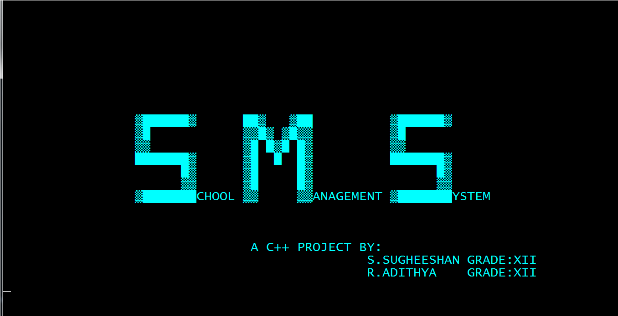

**Admin page**

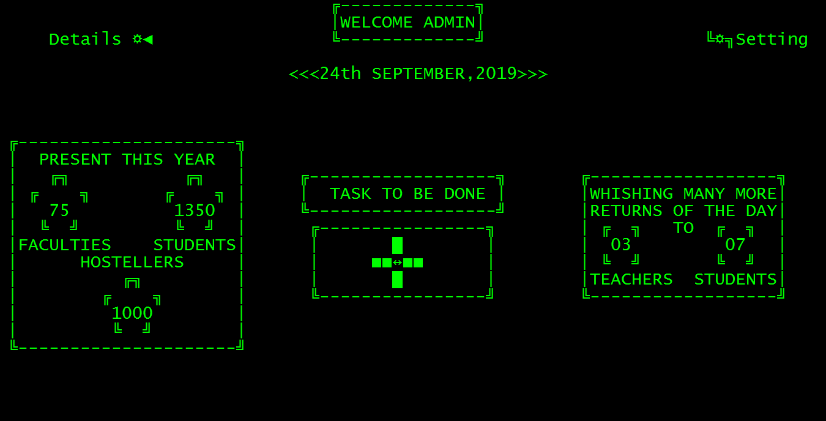

**Menu for taskl**

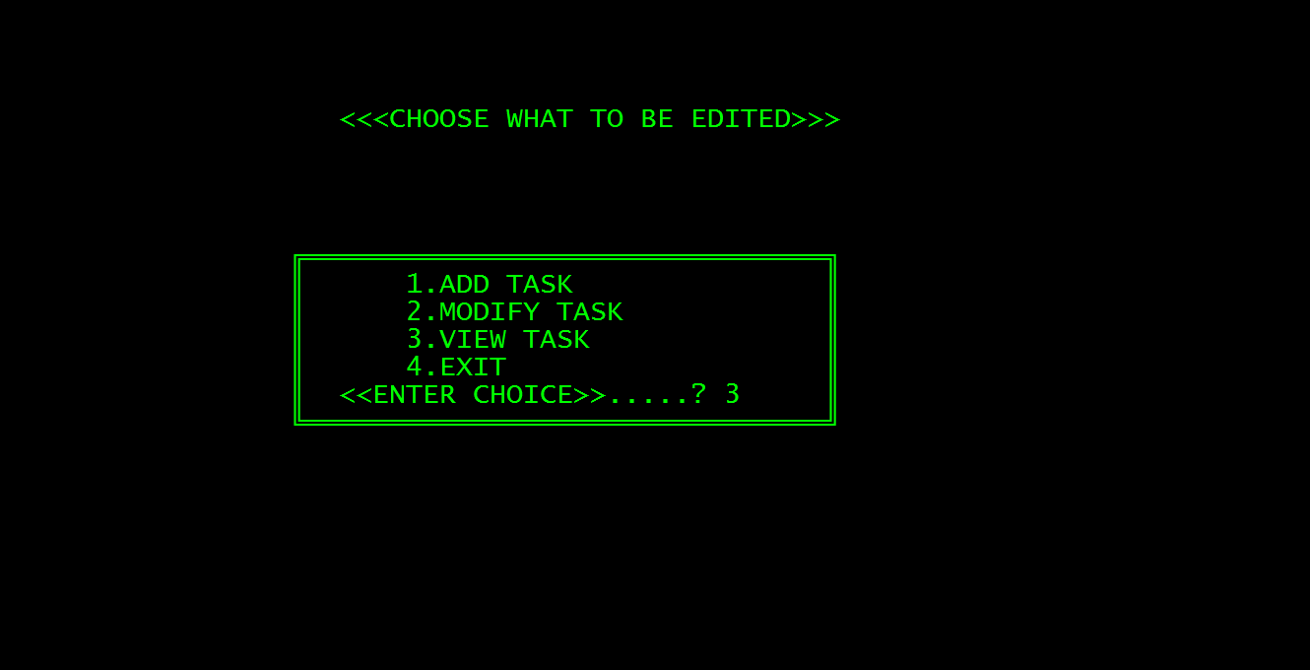

**Page to add the task**

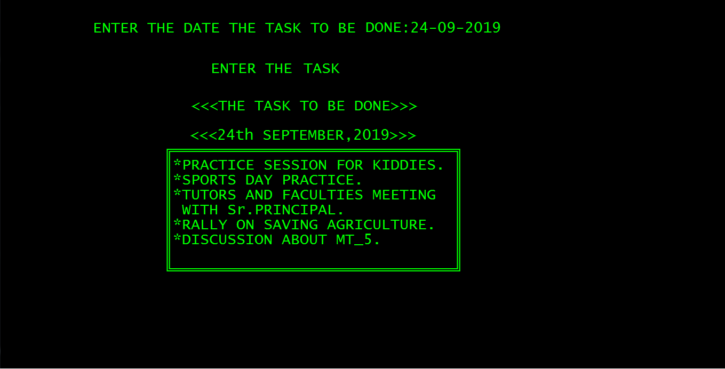

**Page to view task of the day**

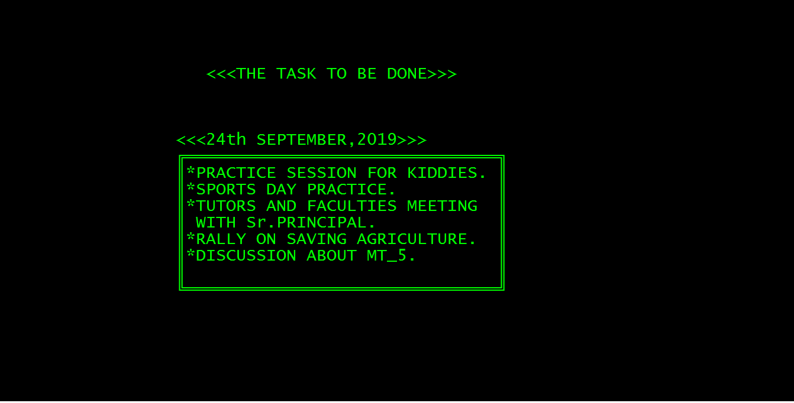

**Students’ menu**

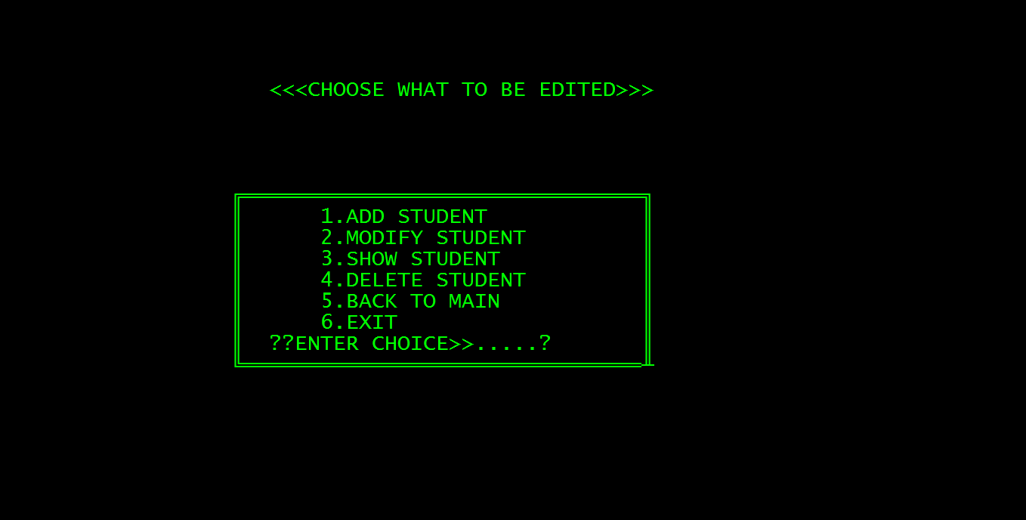

**Page to add new admission**

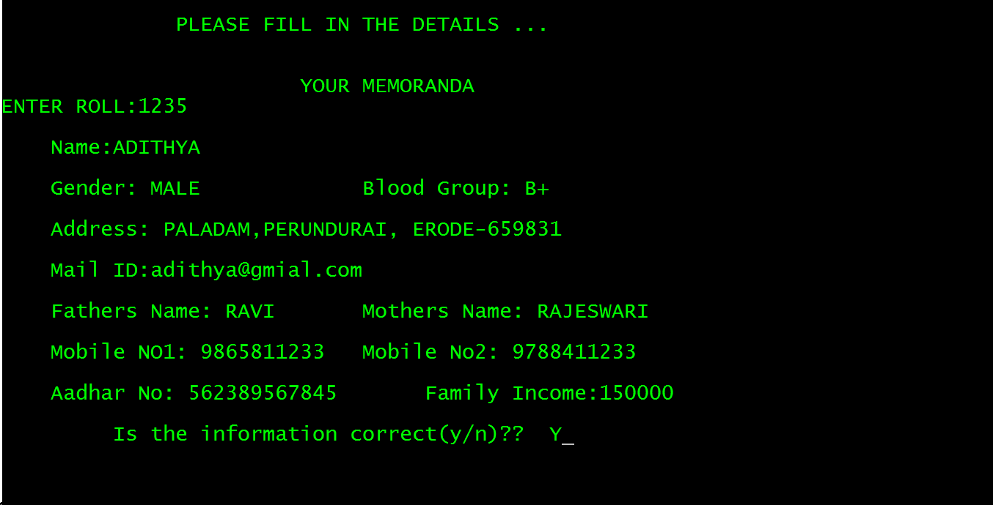

**Page to veiw to students’detials**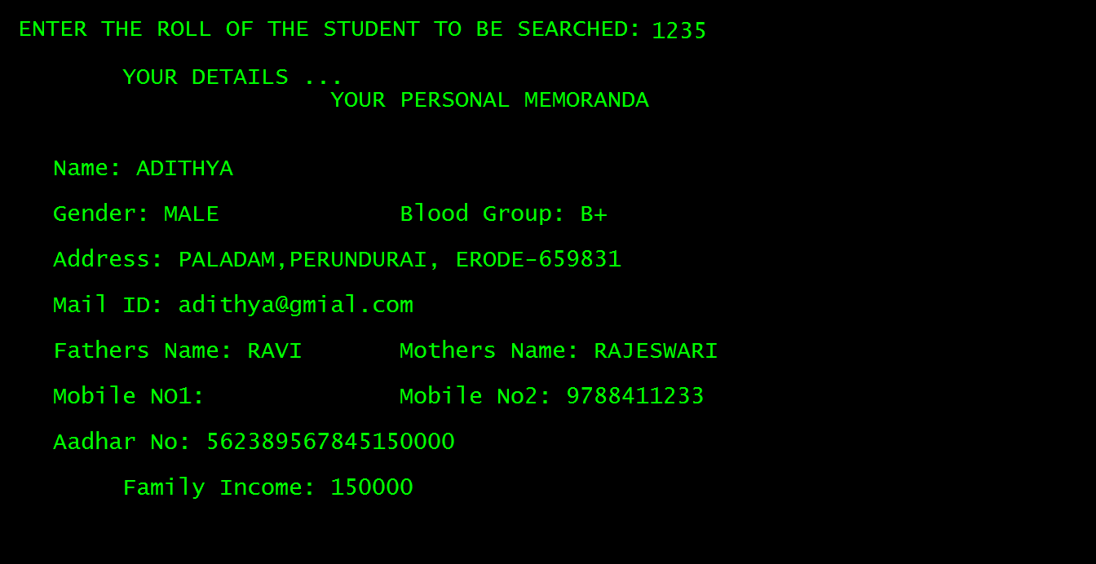

**Pages to modify the details of a student**

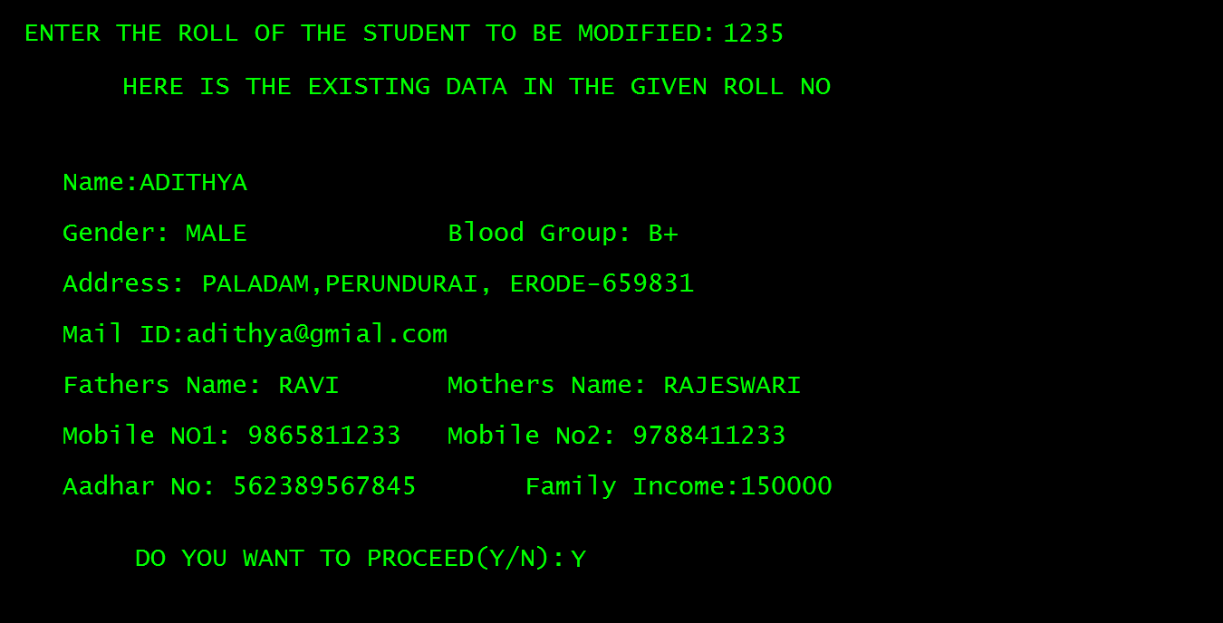

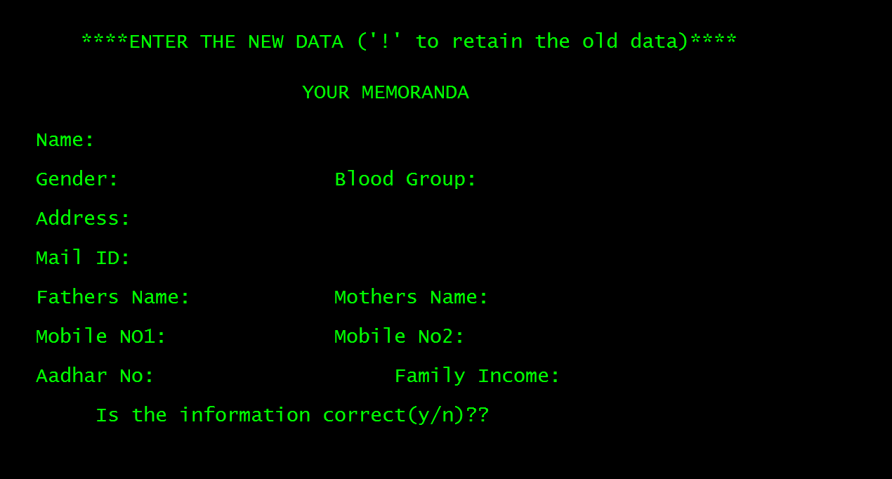

**Teachers menu**

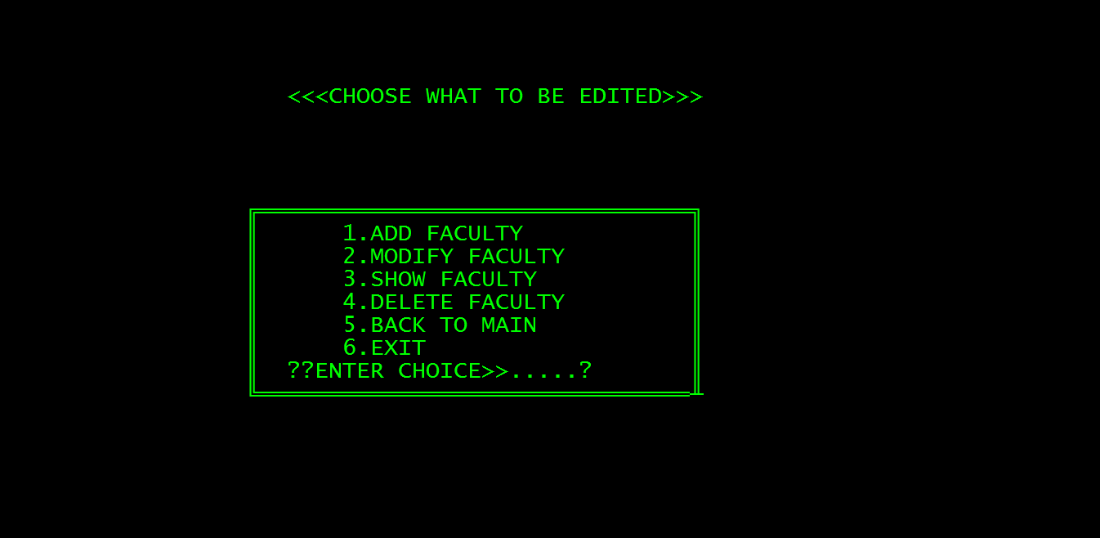

**Adding a faculty**

**Page-1**

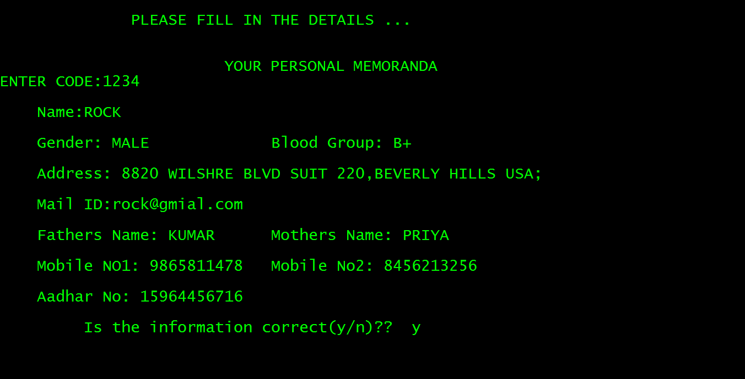

**Page -2**

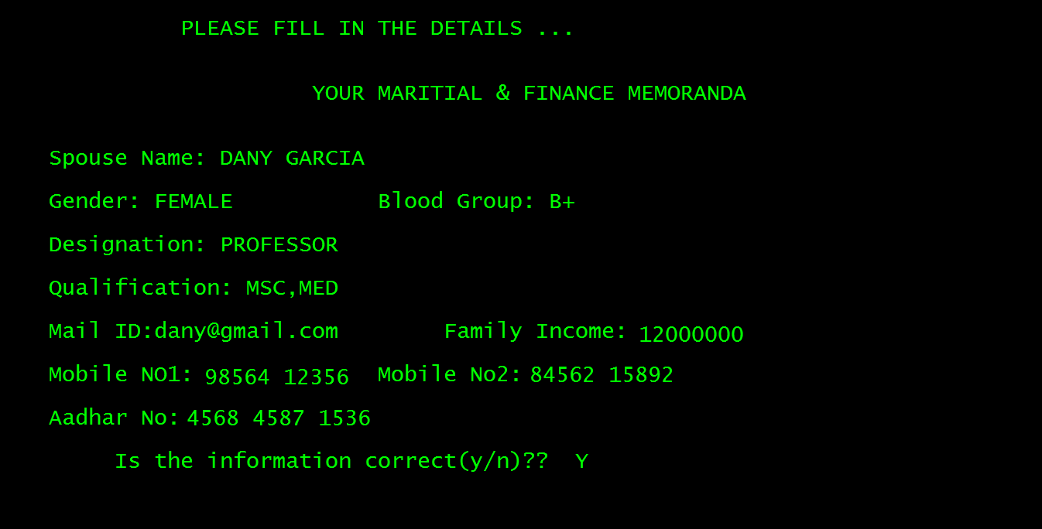

**Viewing teachers**

**Page-1**

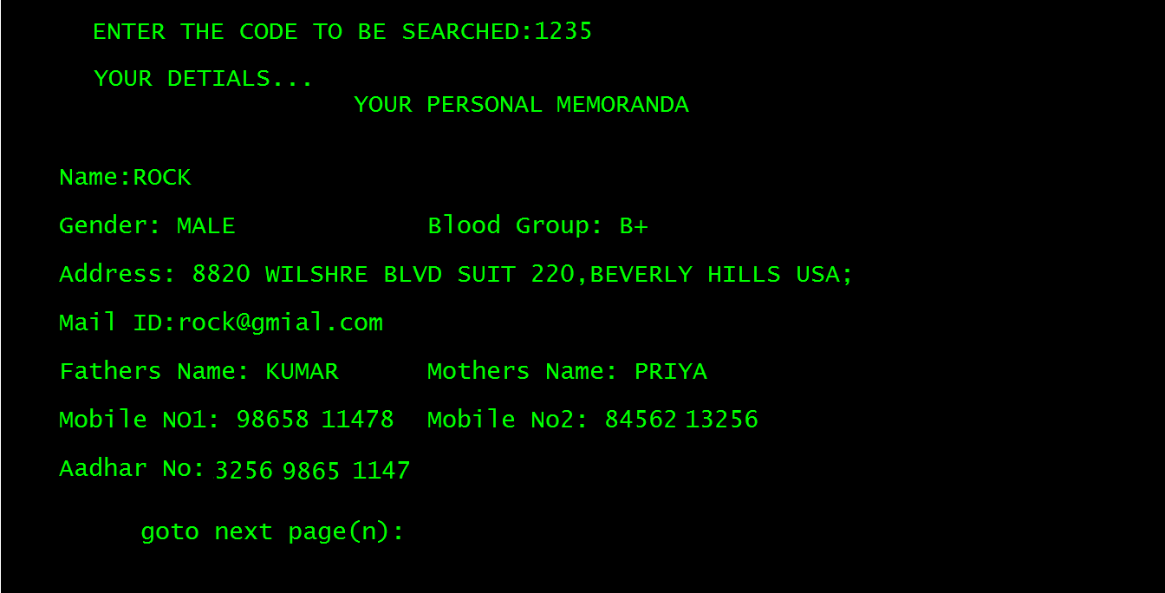

**Page -2**

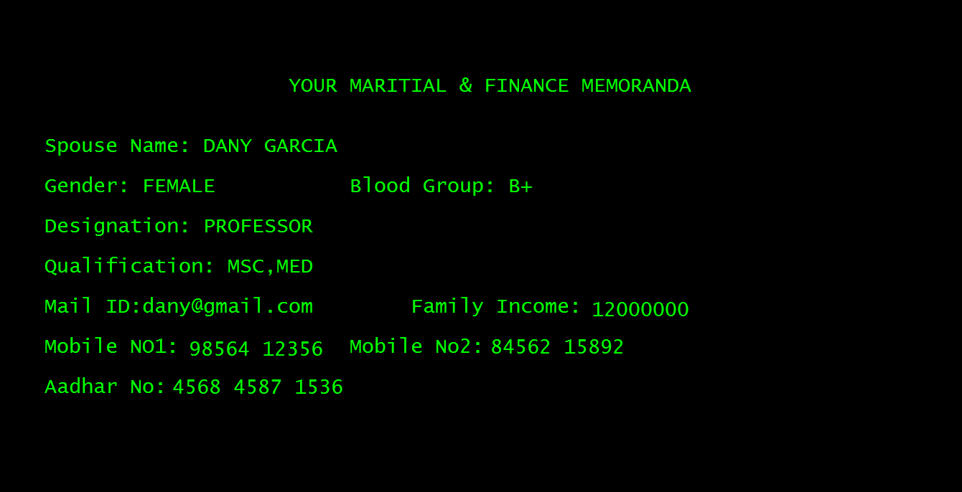

**Modifying teachers’ details**

**Page -1**

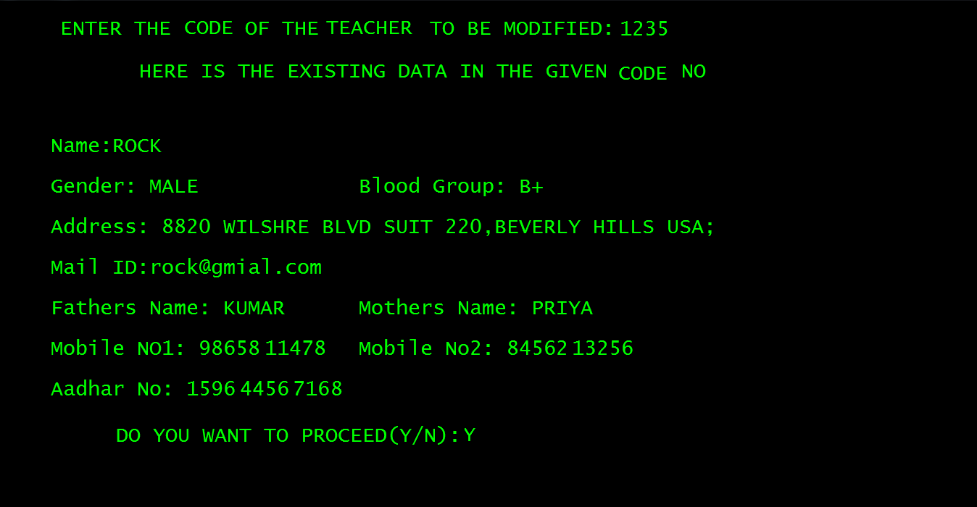

**Page-2**

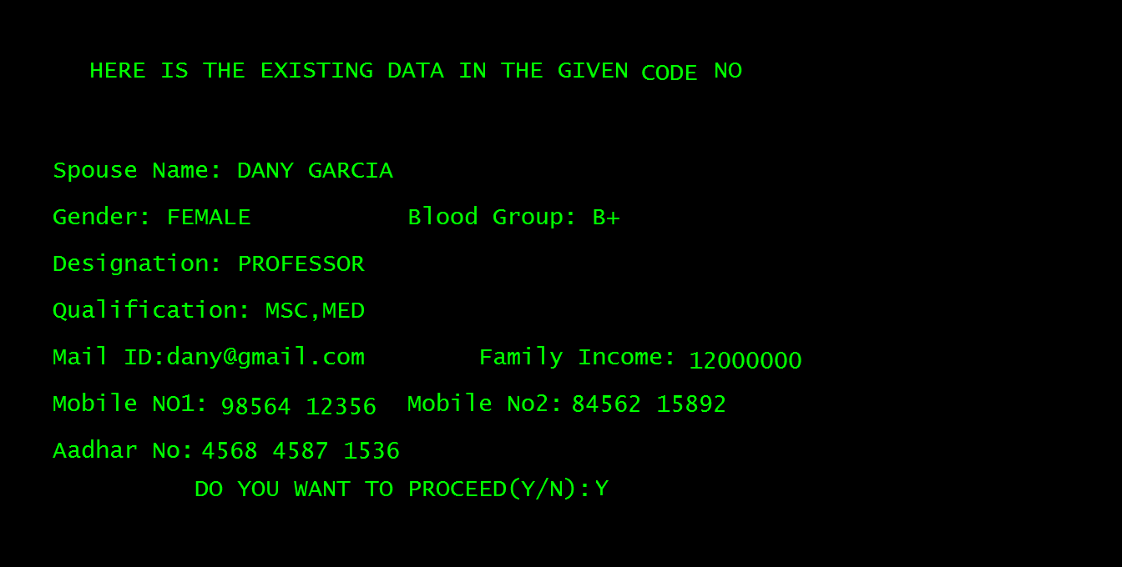

**Page -3**

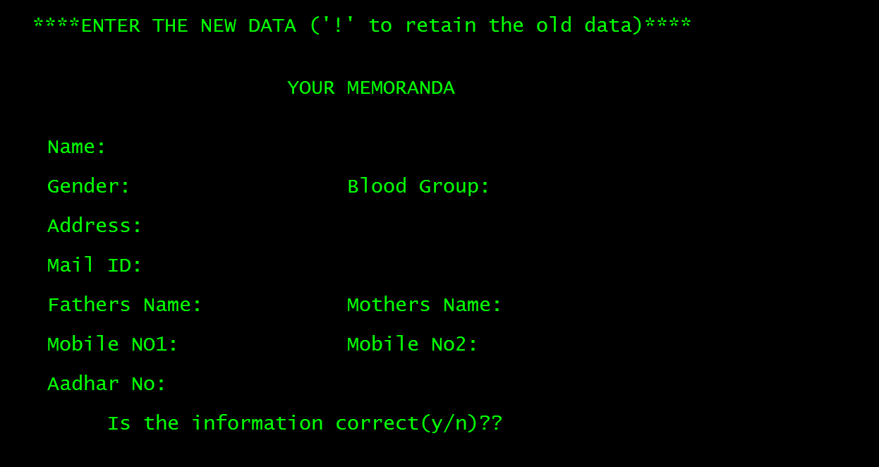

**Page -4**

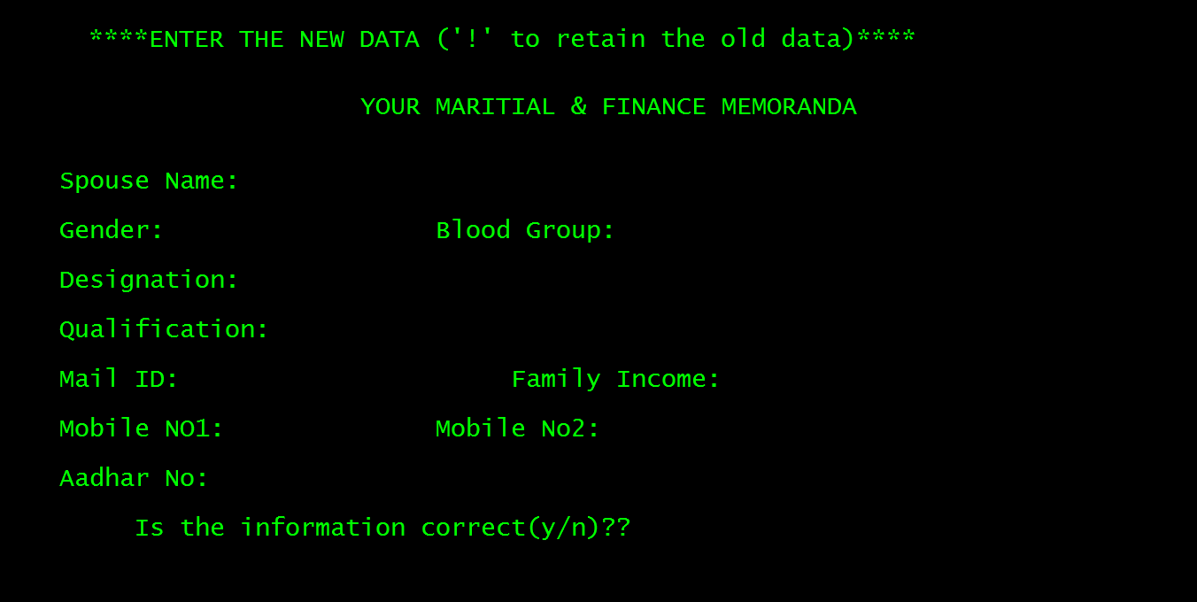

**7. CONCLUSION AND FUTURE ENHANCEMENT**

**7.1. Conclusion**

After completing this project, sure the problems in the existing system would overcome. The “SCHOOL MANAGEMENT SYSTEM” process made computerized to reduce human errors and to increase the efficiency. The main focus of this project is to lessen human efforts. The maintenance of the school records is made efficient, as all the records are stored in the ACCESS database, through which data can be retrieved easily. The navigation control is provided in all the forms to navigate through the large amount of records. If the numbers of records are very large then user has to just type in the search string and user gets the results immediately. The editing is also made simpler. The user has to just type in the required field and press the update button to update the desired field.

Our project is the updated version of processing the data in the school by hand written format where exist inconsistency and data redundancy .When we discussed with many of the rural schools they were not having any of the software for maintaining the details of the students and the info of their stocks, Many of the  commercial software are at high cost which is out of their reach. And it is expected that this project will go a long way in satisfying user’s requirement.

**7.2. Future Enhancement**

The project which we have made is easily accessible and affordable. When someone in the future takes up enhancing this project it can be easily implemented under various situations. This project provides user friendly environment so that user can interact with system easily. Its flexibility towards the user through the entire module can be enhanced in an effective way creating link with a group or an individual.

**SOFTWARE SCOPE**

* **Extensibility**

This software is extendable in ways that its original developers may not expect .The following principles enhance extensibility like hide data structure, avoid traversing multiple links or methods, avoid case statements on object type and distinguish public and private operations and also can go on with the networking so that it could be easily accessible by the parents to view the progress of their ward by the way this could also create a link between the faculty members for developing the needs of the school and the students.

* **Reusability**

Reusability is possible as and when require in this application. We can update it next version. Reusable software reduces design, coding and testing cost by amortizing effort over several designs. Reducing the amount of code also simplifies understanding, which increases the likelihood that the code is correct.

* **Understandability**

A method is understandable if someone other than the creator of the method can understand the code (as well as the creator after a time lapse). We use the method , which small and coherent helps to accomplish this.

* **Cost-effectiveness**

Its cost is under the budget and make within given time period. It is desirable to aim for a system with a minimum cost subject to the condition that it must satisfy the entire requirement .Scope of this document is to put down the requirements, clearly identifying the information needed by the user, the source of the information and outputs expected from the sys